Free School Meals Application.
To apply, visit www.solihull.gov.uk/FSM and you will arrive at this page. Click on the green button that says Apply for Free School Meals. 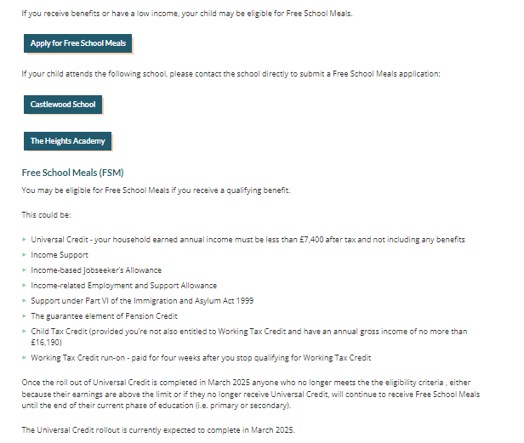
You should then be taken to this page. Click on Login under Free School Meals to access your account.
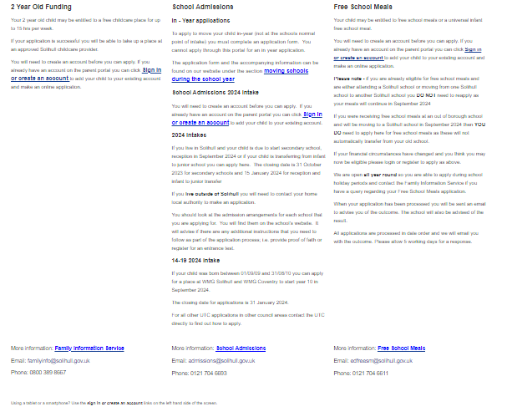

Enter your details to sign in.
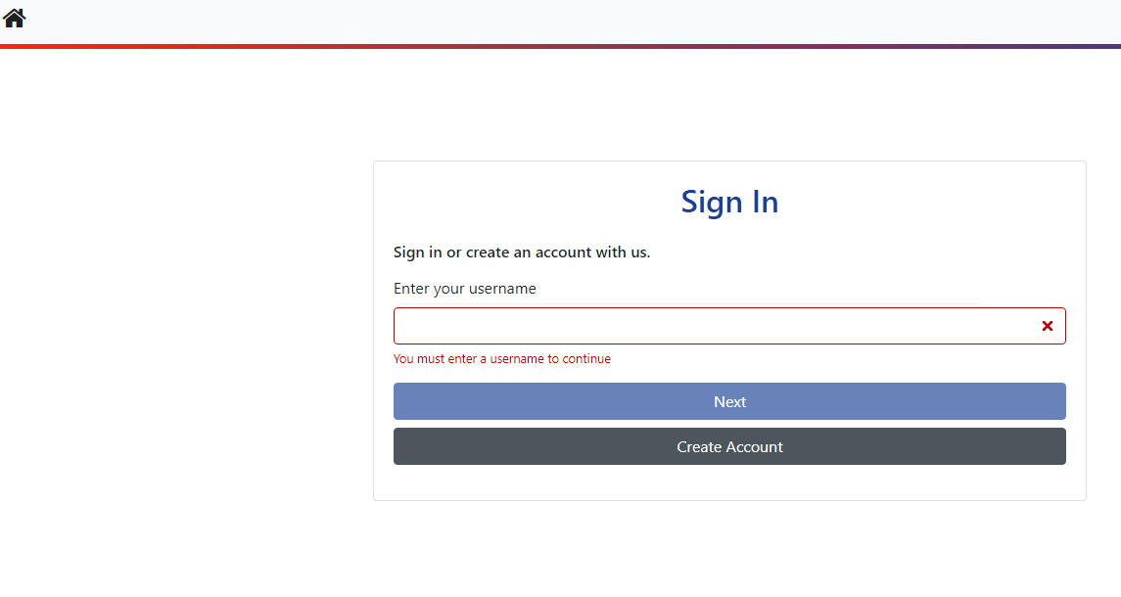
You should then see this screen which shows your details and your children’s details. This information has been removed to protect identity.
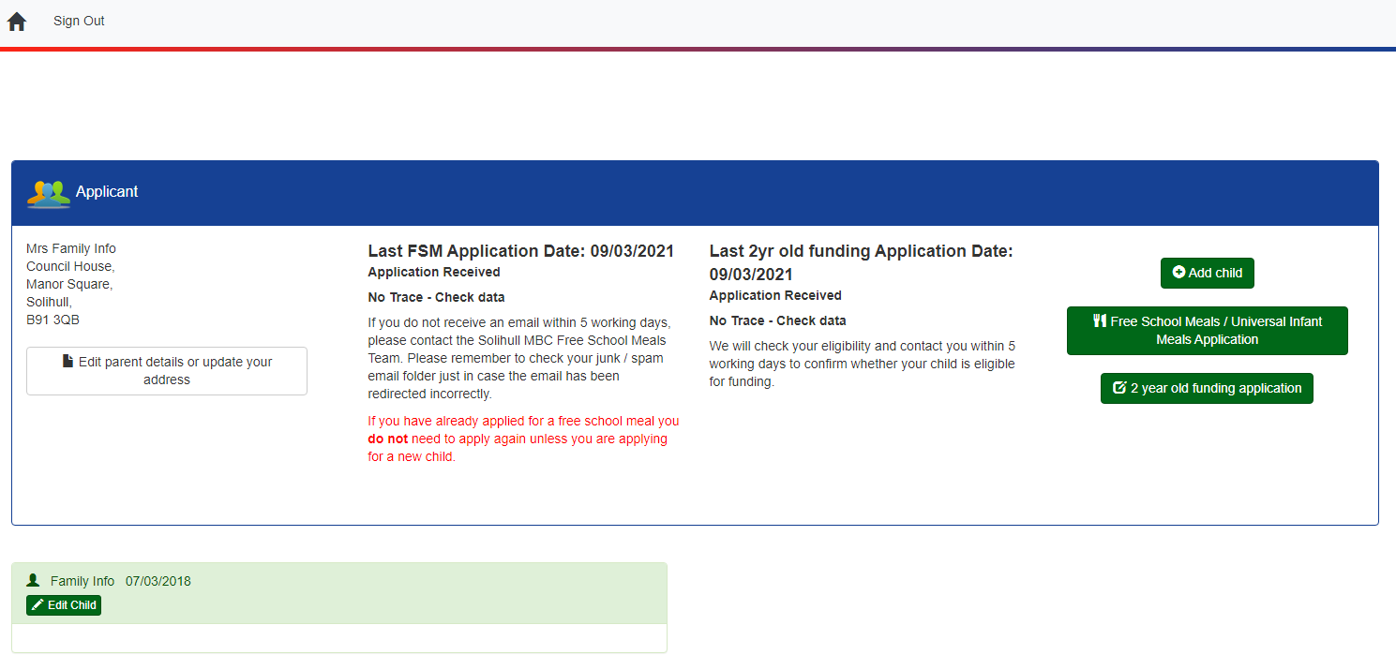
If your children aren’t listed, click add child first and add their details.
Once your child is showing, click Free School Meals / Universal Infant Meals Application. Enter your National Insurance (NI) Number or NASS, and your date of birth. Then click “Free School Meals / Universal Infant Meals Application”.
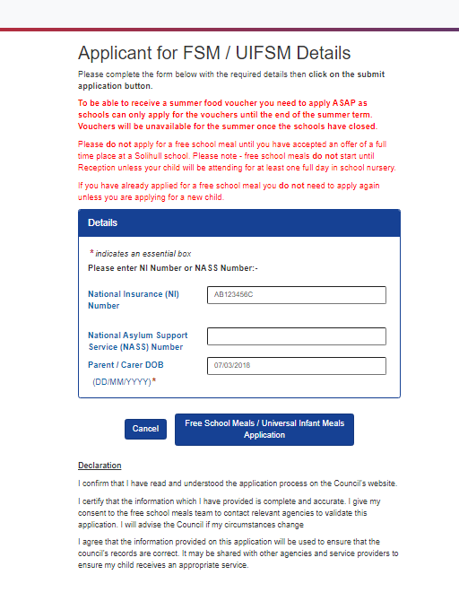
After completion press Free School Meals / Universal Infant Meals Application to send the application and if it has gone through you will receive an email confirming that your application has been sent. Applications are normally processed within five working days but at busy time this may take a little longer.

